


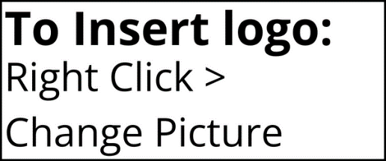

MAKING THIS A BETTER PLACE TO WORK
DEVELOPING OUR ORGANIZATION
IDENTIFYING WHAT DRIVES PEOPLE TO BE ENGAGED
YOUR FEEDBACK CAN ASSIST US IN:
WHO TO CONTACT
We thank you in advance for helping make our organization an even better place to work. If you have any questions or concerns, please reach out to:
(Survey administrator contact information).
WE NEED TO REACH YOU
Please make sure your contact information is up to date with Human Resources. You will be able to participate in the survey via (enter method – email/text/phone call, etc.).
In the spirit of continuous improvement, we’re conducting a/an (survey name) survey on (date or if a new hire survey, enter the number of days/anniversary). Your involvement gives us the opportunity to hear the collective voice of our workforce and take targeted action. We’re using a third-party platform, People Element, to collect your feedback.

People Element was selected as a third-party partner to ensure all individual responses are kept confidential, so please provide your honest feedback.
YOUR RESPONSES ARE CONFIDENTIAL
WE WANT YOUR FEEDBACK!

